Residual Energy and Density Control Aware Cluster Head Election in Wireless Sensor Network

MEDDAH Meriem¹, HADDAD Rim², EZZEDINE Tahar³

¹Innov’Com Laboratory
National Engineering School of Tunis University Tunis El Manar
Email: meddah_meriem@hotmail.fr
²Innov’Com Laboratory
High School of communication of Tunis University of Carthage
Email: rim.haddad@yahoo.ca
³Sys’Com Laboratory
National Engineering School of Tunis University Tunis El Manar
Email: tahar.ezzedine@enit.rnu.tn

Abstract—In designing the Wireless Sensor Network, the energy consumption represents one of the most and important factor that recent researches aim to reduce efficiently. Because of the limited energy that sensor nodes are equipped with, and in order to prolong the network lifetime, we introduce a new clustering algorithm for WSN, which consists on choosing a subset of sensor nodes to be elected as Cluster Heads. This choice is based on three parameters; the residual energy, the density and the distances separating the node with its neighbors. Each node enters into a competition and makes its proper decision. Then, the network is divided into clusters and each member is affected to the nearest CH that has the job to gather the data of the members of its cluster. The efficiency of our proposed algorithm is proved comparing with some other clustering approaches. Simulation results show that the energy dissipation of the sensor nodes can be considerably reduced, and the network lifetime efficiently extended.
Keywords— Wireless Sensor Networks; Residual Energy; Cluster Head election; Density ; Neighbor Distance

Introduction
Over recent years, the importance of Wireless Sensor Networks (WSNs) in different domains is considerably increasing. It consists on a group of small sensor nodes capable to detect and monitor physical conditions from the field, and then to transmit data to the Base Station (BS) once gathered. These nodes are very low-cost and are capable to perform as an autonomous device, but have less storage capacity and a limited battery power, that can be depleted very quickly, due to the multiple tasks made, such as processing and exchanging packets with nodes.
The most important challenge in WSN is to extend the network lifetime. This can be achieved when the energy consumption is efficiently used, and balanced among nodes. Many clustering algorithms proposed in the last few years have the objective to improve this goal, and are focused on how to regroup the sensor nodes deployed into clusters. Each created cluster will have a Cluster Head (CH). This node, elected in each round, collect data from the other members of the cluster, and then send it to the BS.
Furthermore, to reduce energy consumption, previous researches in WSN have been done, considering the residual energy as parameter [1] [2] [3], taking into consideration the communication cost, the required amount of energy needed for a node to send a message to another one [4], or calculating a weight for each node to be compared [3]. Also, a random number was used in order to have a balanced CH election in the network [5] [6]. These different parameters are used to elect the suitable CH. But for the clustering step, in some researches, the whole network is divided into several clusters, choosing the number of clusters before each round of the clustering process [7].
In this paper, a new distributed and competitive algorithm, named Cluster Head Election using Residual Energy and Density Control (CHEREDC) for wireless sensor network is proposed. In the CH election, each node in the network enters into an energy and density comparisons. In our algorithm, each node must compare its Residual Energy and its density with the Residual Energy and the density of the neighbor nodes. In the cluster creation phase, each CH will choose the set of member nodes to be affected to its cluster.
The remainder of this paper is organized as follows: Section II discusses some of the existing clustering techniques; in Section III the system model is presented; Section IV and V present the proposed algorithms CHEREDC and evaluate its performance comparing with previous algorithms. Finally, we conclude the paper and discuss some possible future works in Section VI.

Related work
Most of the previous clustering approaches have been done aiming to balance the energy consumption of the nodes over the network. In this section, we briefly introduce some of these proposed algorithms.
In Low-energy and adaptive clustering hierarchy (LEACH) [9], Energy-Efficient Unequal Clustering (EEUC) [5], Cluster Head Election mechanism using Fuzzy logic (CHEF) [6] and Multi Objectives Fuzzy Clustering Algorithm (MOFCA) [2] a probabilistic and distributed method is used, where, the node enters into a competition only if its random generated number is less than a predefined threshold value Th. For [5] [6] and [2], the competition is made by neighbors, they communicate and decide together the best node eligible to be elected as CH without any contribution from the BS. Therefore, this method applied in the election of the CH differs from an algorithm to another. In fact, in CHEF, the value of the range is static and considered the same for each implemented node, contrary to MOFCA [2] and EEUC [5] where it can vary, according to the distance separation the node with the BS in [5], or depending on the density, the remaining energy and the distance separating the node to the BS in [2]. The non-collaboration of the BS in the cluster head election process forces the nodes to communicate between each other during the entire phase. This approach did not help decreasing the relayed packets, so the energy consumption of the nodes is increased.
Then, the proposed approach in Fuzzy C-Mean based clustering algorithm (FCM) [10], considers three parameters: the Euclidian distance to partition the network, and the denoted Xie and Beni’s (XB) index to determine the optimal number of cluster. The CHs elected in this algorithm are approximately positioned at the center of their clusters and the inter-cluster distance is not considered. Contrary to LDC-kmean algorithm [7], Residual energy aware mobile data gathering in WSN (REAMDC) [3] and Multi-hop Clustering Algorithm Based on Spectral Classification for WSN (MHCA-SC) [11] where the Euclidian distance is the only parameter considered in the clustering step. In [7], the number of members node assigned in the clusters is counted. This number can vary between two values: N/K – δ and N/K + δ, where N represents the number of nodes, K the number of clusters chosen in the beginning of the clustering step and δ a parameter set equal to 0%,2% or 3% of N. Next, the closest node to the center of each cluster is elected as CH. As we remark, the energy consumption model is not studied in [7] [9] and [10]. These algorithms present many disadvantages in terms of consumed energy by the deployed nodes, which are not balanced over the network. In the recent researches, most of the proposed algorithms consider the energy consumption in the election of CHs because of the amount of energy that CHs need to gather the sensed data from cluster’s member, and send them to the BS [2] [5] [6] [12] [14].
In [3] and [8], the election of the CHs requires a comparison of the weight between sensor nodes in the cluster. The node with a greater weight is the best one eligible to be elected as CH. In Tree-cluster-based data-gathering algorithm for industrial WSN (TCBDGA) [13], Weight-Based Trees are established and considered as clusters using the residual energy, the number of neighbors, and the distance to the BS as parameters to be compared. The CHs are the nodes in each head of the created trees.

System model

Network structure
The evaluation of our proposed CHEREDC algorithm is done in an operational environment. We consider an M×M square area, where N sensor nodes, marked by a unique ID, are randomly deployed and are stationary after the deployment. At the beginning, all the nodes have the same amount of energy, equal to 1 Joule (J) and have the same communication range denoted by R and set equal to 10. In each round, each node establishes a routing table of neighboring nodes based on the received data from the BS, which contains information of all nodes within its communication range. The packet received from the BS contains the distances between the node and its neighboring nodes, the current energy of each neighbor, and the predicted energy consumed to send a packet to a neighbor node. The BS is located at the center of the area and the communication is based on a single-hop manner. Each node has to send its sensed data to its respective CHs, next, the latter sends the gathered packets to the BS.

Energy consumption model
The energy consumption model adopted here is the same in [1]. The energy consumed to transmit and to receive l-bit packets over a distance d is given respectively in Equation (1) and Equation (2). Where E_{elec} represents the degenerated energy per bit in the transmitter and receiver models. The parameter ε_{fs} and ε_{mp} denote respectively the amplifier energy in a free space model with d² power loss, and in a multi-path fading model with d⁴ power loss, according to a threshold estimation of the transmission distance d_{o}, which can be obtained by Equation (3).
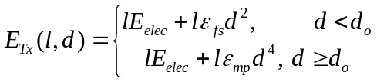
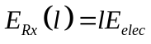
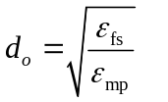

CHEREDC Algorithm
In CHEREDC algorithm, the clustering approach consists on a distributed and competitive scheme, where each node decides about its proper status: to be elected as CH node or as member node. The parameters taken into consideration in the comparison made by each node are: the residual energy of nodes, the neighbor distance and the density. In Fig. 1, a flowchart of the proposed CHEREDC is shown. The proposed algorithm consists of four steps:
- Routing table’s creation.
- CHs election.
- Choosing cluster members.
- Data aggregation.

Routing table’s creation
In each round, the BS has the job to calculate the routing table (RT) for each Node i deployed and still alive in the network. The routing table will contain information about the neighbors: sensor nodes situated in its range R, and we consider here that the range R is the same for all sensor nodes. For a certain neighbor j of Node i, these information are: The unique ID RT_{i}.ID(j) the residual energy RT_{i}.E(j), the position RT_{i}.coor(j), the density RT_{i}.dens(j) and the remained energy needed for Node i to send a packet to Node j RT_{i}.Endiss(j).
Fig. 1 A flowchart of the proposed CHEREDC algorithm

The density of a node i is calculated in Equation (4). As mentioned in the previous section, all sensor nodes have the same amount of energy equal to 1J. We consider that in the data aggregation step, nodes have to inform their CHs with their residual energy, as to be communicated to the BS, in order to create the RTs for the next round.
Once created, the BS sends for each Node i its routing table RT_{i}. On providing sensor nodes by the neighboring information, the BS reduces a large amount of tasks that each node has to do. Hence, the local energy of nodes can be preserved.

CHs election
In this phase, the CHs will be elected. Each node enters into a comparison phase, and decides either it will be a CH or a member. In each round, as mentioned above, Node i receive a new RT_{i}: a routing table containing all the informations about its neighbors.
In this algorithm, N_{i}.Stat represents the status of the node i. In fact, the node i sets its status as CH in the beginning, and then depending on the comparison that will be done, its status can be changed as Member or left as CH. Each node compares its residual energy with the residual energy of each neighbor. If the node i finds one of its neighbors, denoted Node j with a residual energy upper than E(i), Node i have to set its status as Member. In case of E(i) equal to RT_{i}.E(j), the density is compared and the sensor node i will be considered as more eligible to be CH if its density dens(i) is greater than RT_{i}.dens(j). Each node calculates its density in each round considering Equation (4).

Considering the approach presented above, we have the certainty that only one CH will be elected in each range R. After the setup phase, and in order to inform its neighbors, Node i broadcasts a message to inform the other nodes about its status.

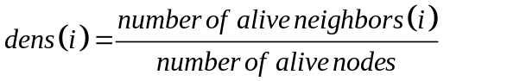

Choosing cluster members
In the third step of the proposed CHEREDC algorithm, clusters will be formed according to the distances between nodes and CHs. Each elected CH will select the nearest M sensor nodes, where M is a certain value representing the desired size of each cluster. The CH sends an InvitationMessage for the M nearest chosen nodes. This message is an affiliation request that each CH has to send in order to create its cluster member, considering the neighbor distances. After this step, CH still waiting for the AcceptedInvitation messages, which is a message sent by a member node. The Member node i can receives zero or more InvitationMessage, and on receiving each InvitationMessage from CH j, Node i affect the CH j to a subset denoted by SCH_{i}.
Then, the Member node i chooses one of the CHs in SCH_{i}(j), considered as the closest one chosen from the sets of CHs and sends it an AcceptedInvitation message. The number
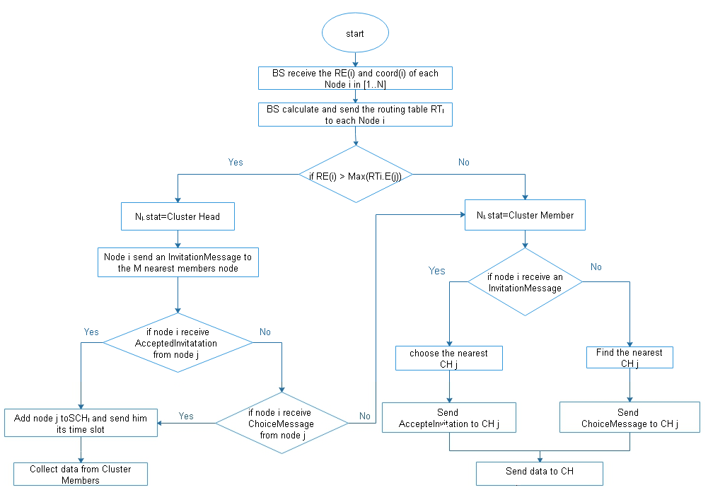
of AcceptedInvitation message received by each CH varies between 0 and M, and in the case where the node did not receive any AcceptedInvitation, the node sets its status a Member and affects itself to the nearest CH j. Using this approach number of assigned nodes in the clusters is balanced.

Data aggregation
Once the clusters are formed, each CH collects data from members affiliated to its cluster and sends the packets to BS. Each member node sends a packet which contains its sensed data to the CH, and then goes to a sleeping phase to prevent needless energy consumption.
In the previous phase, we have explained how the cluster size is balanced over the network, so the data delivery process is more equilibrated, by consequence it is less time consuming.

Simulation results

In this section, simulation results are shown applying the clustering algorithm presented in the previous section. First, we evaluate our proposed approach with different locations of the BS in both cases: inside and outside the area, and for two different values of the parameter M. Second, we present the impact of the parameter M on the CHs election as well as their energies consumption. Finally, we compare our algorithm with other achieved ones namely LEACH, Hybrid, Energy-Efficient, Distributed Clustering Approach (HEED) [14] and DSLBCA [8].
The proposed algorithm is developed using MATLAB R2010a. The deployment of sensor nodes is random and nodes are distributed through an area of 200 x 200 meters. TABLE I contains the different values of the parameter used for the presented simulations. For a fairy comparison, we use the same metrics as in [15] which are: the First Node Dies (FND), the Half of the Nodes Alive (HNA) and the Last Node Dies (LND).

- Configuration parameters

Parameter | Value
N (Number of deployed nodes)  R (Range of nodes in meter)  E_{elec}  ε_{fs}  ε_{mp}  E (Initial energy of nodes)  ctrPacketLenth  PacketLenth | 200  10  50nJ/bit  10pJ/bit/m  0.0010pJ/bit/m4  1J  2000bits  4000bits

Variation of the BS’s location

Scenario 1

In order to prove the effectiveness of our proposed approach, a variation of the BS’s location is proposed. For the first scenario, M is set equal to 1, which means that for each round in the cluster’s creation, each CH has to send only one InvitationMessage to the nearest neighbor, either if the number of its neighbors is equal or greater than M. We simulate the proposed algorithm for three different positions of the Base Station. The variation of the network lifetime is depicted in Fig. 2. To compare the simulation results, the parameters First Node Dies FND, Half of the Nodes Alive HNA and Last Node Dies LND are considered.
The values of the simulation are presented in TABLE II, with a FND in the round of 119 and 40, respectively for (XBS=0;YBS=0) and (XBS=250;YBS=250). We remark that for a position of the BS in the border or outside of the area, the proposed algorithm performs more. In this case, the first node dies in the round of 1003, in the round 1521, half of the nodes still alive and finally the last node dies in the round of 2693.

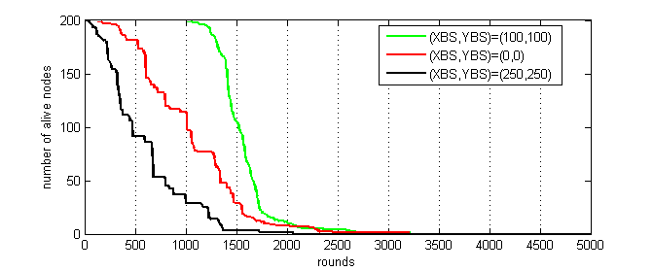
Fig. 2 Number of nodes alive vs BS’s location for M=1

- Simulation results
for CHEREDC algorithm (M=1)

(XBS,YBS) | FND | HNA | LND
((100,100)  (0,0)  (250,250) | 1003  119  40 | 1521  1009  470 | 2693  2475  2063

Scenario 2

In this case, the positions of the BS are as mentioned in the first scenario. Therefore, the value of the parameter M is not fixed anymore, it differs from a node to another. We consider that in each round, each CH sends an InvitationMessage to all the members in its RT_{i}. The number of invitation message can vary from 0 to the number of sensor nodes situated in its range R. As mentioned in TABLE I, this range R is equal to 10, which means that each node situated in a distance separating it from a CH i and lower than R, will receive an InvitationMessage from this CH.
In fig. 3, we present the network lifetime for the three different positions of the BS. As we can observe, the best results are obtained when the BS is at the center of the network for the value of the FND and HNA. The FND and HNA are in the round of 757and 1415 (see TABLE III). Therefore, the number of alive nodes depletes quickly when the position of the BS is in the border or outside of the area (as in scenario 1) with FND value in the round of 200 for XBS=0 and YBS=0, and 120 for XBS=250 and YBS=250. The HND values are 1039 and 543 respectively when the BS is in the border of the area and outside. As we can see, the position of the BS doesn’t have an impact when the LND is considered. For the three tested positions, the LND is in the average of 4878. This is due to the number of InvitationMessage sent that is decreasing with the decrease of the number of neighbors. Then, the attitude of the curve becomes the same for the three cases between round 200 and 4880.

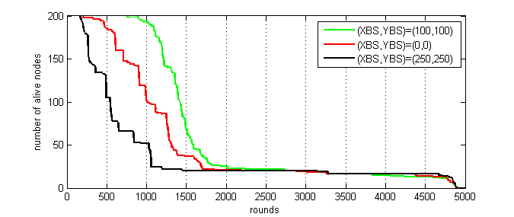

Fig. 3 Number of nodes alive vs BS’s location for M=Nb of neighbors

- Simulation results for CHEREDC
algorithm (M=number of neighbors of nodes)

(XBS,YBS) | FND | HNA | LND
(100,100)  (0,0)  (250,250) | 757  200  120 | 1415  1039  543 | 4884  4878  4874

Number of elected CHs

In the CHs election phase, each node sets up its status, either to be a CH or a member sends an InvitationMessage to certain nodes and waits for a response. If the CH did not receive any AcceptedInvitation, it sets its status to member and finds the nearest CH to be affiliated to. The number of InvitationMessages sent has an impact on the maximum number of created clusters. Fig. 4 presents the number of CHs elected between the 50th and the 100th round, the number of elected CHs is greater when M=1 for the different locations of the BS, either inside the area, with the values 78 and 67, or outside the area with values that varies between 75 and 95.
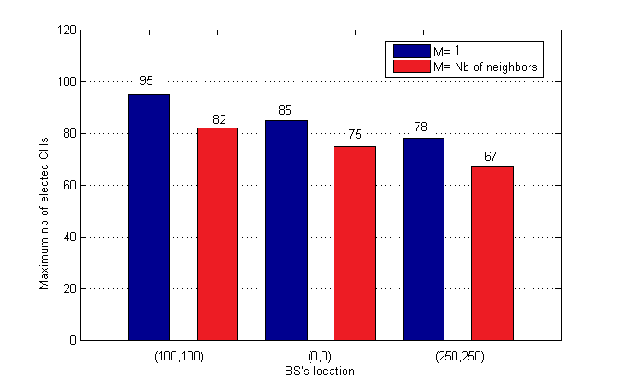
Fig. 4 Maximum number of elected CHs between the round 50 and 100

Number of packets sent to the BS

We compare the number of packets sent to the BS for the three different positions of this latter, when the parameter Mis set equal to the number of neighbors (M(i)=Nb of neighbors(i)) (see Fig. 5). As we can note, when the BS is located at the center of the area, the number of packets sent by the CHs is twice the number of packets sent when the BS is outside of the area. This is due to the large number of CHs that die very quickly due to the huge amount of energy required for transmission when the distance separating them from the BS is longer. TABLE IV contains the values of the maximum number of packets sent to the BS for the different BS locations. For (XBS,YBS)=(100,100), the CHs send 7,48 x 10⁴ packets to the BS. Therefore, for (XBS,YBS)= (0,0) and (XBS,YBS)= (250,250) the number of received packets are respectively 4,85x10⁴ and 2,92x10⁴.

- Packets sent to the BS with respect to
the number of rounds (XBS,YBS)=(100,100)

(XBS,YBS) | Maximum nb of packets sent (x10⁴)
(100,100)  (0,0)  (250,250) | 7,84  4,85  2,92

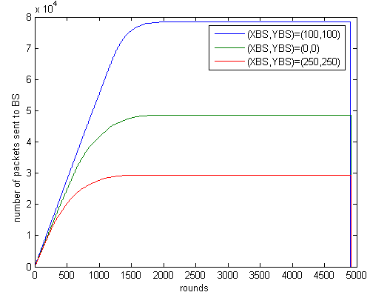

Fig. 5 Number of packets sent to the BS for (XBS,YBS)=(100,100)

Comparison with other algorithms

We compare the experimental results of our proposed algorithm with three other achieved one, namely DSLBCA, LEACH and HEED. In this subsection, we use the parameters presented in TABLE I. The comparison is made on the bases of FND, HNA and FND. .
To provide better results, we choose to set the location of the BS at the center of the area and the parameter M equal to the number of neighbors. As we can depict from Fig. 6, our proposed CHEREDC algorithm performs better than DSLBCA, HEED and LEACH. For CHEREDC algorithm, the stability period is longer than the other one because the FND is in the round of 757. Therefore, this value is in the round of 180, 224 and 96 for DSLBCA, LEACH and HEED respectively. This is due to the decrease of the amount of packets exchanged between nodes in the Routing Tables creation and CHs election phases. Also, the reduction of the number of exchanged packets has an impact on the network lifetime, which provides best results comparing with the other algorithms. The LND is in the round of 4884 for our proposed algorithm, but for DSLBCA, LEACH and HEED it varies between round 1544 and 2404. We deduce that our CHEREDC algorithm extends efficiently the network lifetime.
Fig. 6 presents the performance of our proposed algorithms compared with EEUC, MOFCA, CHEF and LEACH algorithms.

- Values of FND and HNA metrics
for each algorithm

Algorithm | FND | HNA | LND
CHEREDC  DSLBCA  LEACH  HEED | 757  180  224  96 | 1415  1660  1191  1327 | 4884  2404  1544  1577

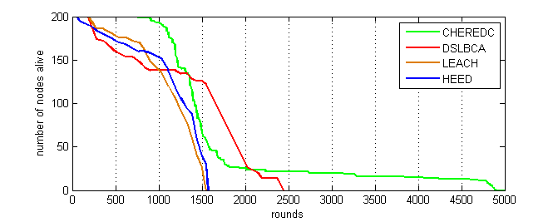

Fig. 6 Variation of the number of nodes alive according
to the number of rounds for different algorithms

CONCLUSIONS AND FUTURE WORK

This paper presents a novel Cluster Head Election using Residual Energy and Density Control algorithm. The main advantage of our proposed approach is that it gives the opportunity for the entire implemented nodes to enter into a competition between neighbors in the election of CHs, comparing their residual energy and their densities. Simulations results are presented and compared with DSLBCA, HEED and LEACH algorithms. It shows that our algorithm performs better than the other one, considering the network lifetime.
All of our contributions focus on the clustering step. For future work, it is interesting to study the behavior of the network lifetime when a Mobile Collector is implemented for the data gathering phase. This technique can be designed to reduce the energy consumed by the CHs in order to send the packets to the BS.

References

- Ye, M., Li, C., Chen, G., & Wu, J. (2005, April). EECS: an energy efficient clustering scheme in wireless sensor networks. In Performance, Computing, and Communications Conference, 2005. IPCCC 2005. 24th IEEE International (pp. 535-540). IEEE.
- Sert, S. A., Bagci, H., & Yazici, A. (2015). MOFCA: Multi-objective fuzzy clustering algorithm for wireless sensor networks. Applied Soft Computing, 30, 151-165.
- Rao, X., Huang, H., Tang, J., & Zhao, H. (2016). Residual energy aware mobile data gathering in wireless sensor networks. Telecommunication Systems, 62(1), 31-41.
- Mehr, M. (2014). Cluster head election using imperialist competitive algorithm (chei) for wireless sensor networks. Int J Mobile Netw Commun Telemat, 4(3), 1-9.
- Mao, Y., & Jie, W. (2005). An Energy-Efficient Unequal Clustering Mechanism for Wireless Sensor Networks. In Proceeding of International conference on Mobile Ad hoc and Sensor System Conference (p. 604).
- Kim, J. M., Park, S. H., Han, Y. J., & Chung, T. M. (2008, February). CHEF: cluster head election mechanism using fuzzy logic in wireless sensor networks. In Advanced communication technology, 2008.
- Raval, G., Bhavsar, M., & Patel, N. (2016). Enhancing data delivery with density controlled clustering in wireless sensor networks. Microsystem Technologies, 1-19.
- Sasikumar, P., Shankar, T., & Khara, S. (2016). Distributed clustering based on node density and distance in wireless sensor networks. TELKOMNIKA (Telecommunication Computing Electronics and Control), 14(3), 916-922.
- Heinzelman, W. R., Chandrakasan, A., & Balakrishnan, H. (2000, January). Energy-efficient communication protocol for wireless microsensor networks. In System sciences, 2000. Proceedings of the 33rd annual Hawaii international conference on (pp. 10-pp). IEEE. W.R.
- Raghuvanshi, A. S., Tiwari, S., Tripathi, R., & Kishor, N. (2012). Optimal number of clusters in wireless sensor networks: a FCM approach. International Journal of Sensor Networks, 12(1), 16-24.
- Jorio, A., El Fkihi, S., Elbhiri, B., & Aboutajdine, D. (2016). Multi-hop Clustering Algorithm Based on Spectral Classification for Wireless Sensor Network. In Proceedings of the Mediterranean Conference on Information & Communication Technologies 2015 (pp. 255-264). Springer International Publishing.
- Handy, M. J., Haase, M., & Timmermann, D. (2002). Low energy adaptive clustering hierarchy with deterministic cluster-head selection. In Mobile and Wireless Communications Network, 2002. 4th International Workshop on (pp. 368-372). IEEE.
- Zhu, C., Wu, S., Han, G., Shu, L., & Wu, H. (2015). A tree-cluster-based data-gathering algorithm for industrial WSNs with a mobile sink. IEEE Access, 3, 381-396.
- Younis, O., & Fahmy, S. (2004). HEED: a hybrid, energy-efficient, distributed clustering approach for ad hoc sensor networks. IEEE Transactions on mobile computing, 3(4), 366-379.
- Yorozu, T., Hirano, M., Oka, K., & Tagawa, Y. (1987). Electron spectroscopy studies on magneto-optical media and plastic substrate interface. IEEE translation journal on magnetics in Japan, 2(8), 740-741.

